9. ReactJS-HOL

ListofPlayers.js

// src/components/ListofPlayers.js

import React from 'react';

*function* ListofPlayers() {

*const* players = [

    { name: 'Virat', score: 85 },

    { name: 'Rohit', score: 95 },

    { name: 'Dhawan', score: 65 },

    { name: 'Pant', score: 78 },

    { name: 'Rahul', score: 55 },

    { name: 'Shreyas', score: 82 },

    { name: 'Hardik', score: 90 },

    { name: 'Jadeja', score: 68 },

    { name: 'Ashwin', score: 45 },

    { name: 'Bumrah', score: 77 },

    { name: 'Shami', score: 60 }

  ];

*const* below70 = players.filter(*player* *=>* *player*.score < 70);

  return (

    <div>

      <h2>All Players</h2>

      {players.map((*player*, *index*) *=>* (

        <p key={*index*}>{*player*.name} - {*player*.score}</p>

      ))}

      <h2>Players with Score Below 70</h2>

      {below70.map((*player*, *index*) *=>* (

        <p key={*index*}>{*player*.name} - {*player*.score}</p>

      ))}

    </div>

  );

}

export default ListofPlayers;

IndianPlayers.js

// src/components/IndianPlayers.js

import React from 'react';

*function* IndianPlayers() {

*const* team = ['Kohli', 'Rohit', 'Dhawan', 'Pant', 'Rahul', 'Shreyas'];

*const* oddPlayers = team.filter((*_*, *index*) *=>* *index* % 2 !== 0);

*const* evenPlayers = team.filter((*_*, *index*) *=>* *index* % 2 === 0);

*const* T20players = ['Suryakumar', 'Chahal', 'Samson'];

*const* RanjiTrophyPlayers = ['Pujara', 'Iyer', 'Saha'];

*const* allPlayers = [...T20players, ...RanjiTrophyPlayers];

  return (

    <div>

      <h2>Odd Team Players</h2>

      {oddPlayers.map((*p*, *index*) *=>* <p key={*index*}>{*p*}</p>)}

      <h2>Even Team Players</h2>

      {evenPlayers.map((*p*, *index*) *=>* <p key={*index*}>{*p*}</p>)}

      <h2>Merged List of Indian Players (T20 + Ranji)</h2>

      {allPlayers.map((*p*, *index*) *=>* <p key={*index*}>{*p*}</p>)}

    </div>

  );

}

export default IndianPlayers;

App.js

// src/App.js

import React from 'react';

import './App.css';

import ListofPlayers from './components/ListofPlayers';

import IndianPlayers from './components/IndianPlayers';

*function* App() {

*var* flag = true;

  //var flag=flase

  return (

    <div className="App">

      <h1>Cricket App</h1>

      {flag ? <*ListofPlayers* /> : <*IndianPlayers* />}

    </div>

  );

}

export default App;

Output:

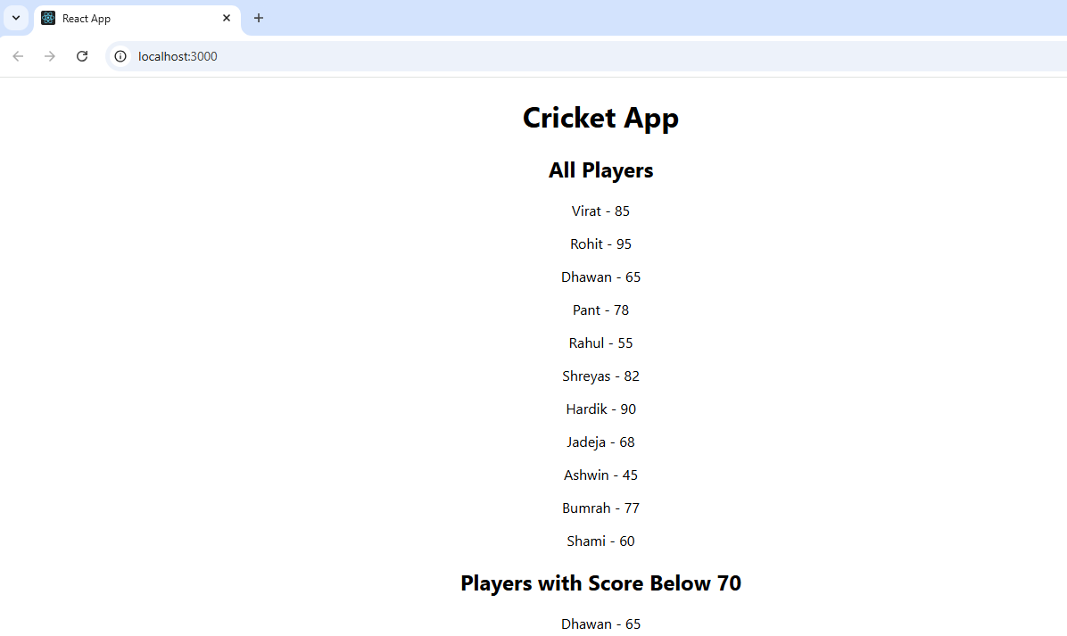

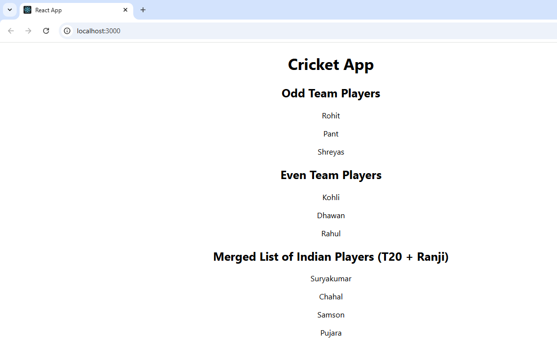

10. ReactJS-HOL

App.js

import React from "react";

import "./App.css";

// List of office space items

*const* officeList = [

  {

    Name: "DBS",

    Rent: 50000,

    Address: "Chennai",

    Image: "http://t3.gstatic.com/images?q=tbn:ANd9GcTy8WkSxm9Jo5WAjh-9ouVC6HVakYQ9otdrgCkA8Ffl1Q_DL6W61Z9slZjCNdH2CslJw4R2XSHZ"

  },

  {

    Name: "Sky Tower",

    Rent: 70000,

    Address: "Mumbai",

    Image: "http://t2.gstatic.com/images?q=tbn:ANd9GcRBGUJEs5FvuD3kNzJJLRGMwghhbuxhHg6ILNIeO3cy-bHeo7BBVrphJ-UJSlyQ44ZbAYP6Vrbc"

  },

  {

    Name: "Tech Hub",

    Rent: 60000,

    Address: "Bangalore",

    Image: "https://images.unsplash.com/photo-1520607162513-77705c0f0d4a?auto=format&fit=crop&w=800&q=80"

  }

];

*const* element = "Office Space";

*function* App() {

  return (

    <div className="App">

      <h1>{element}, at Affordable Range</h1>

      {officeList.map((*ItemName*, *index*) *=>* {

*const* jsxatt = (

          <img

            src={*ItemName*.Image}

            width="25%"

            height="25%"

            alt="Office Space"

          />

        );

*let* colors = [];

        if (*ItemName*.Rent <= 60000) {

          colors.push("textRed");

        } else {

          colors.push("textGreen");

        }

        return (

          <div className="office-card" key={*index*}>

            {jsxatt}

            <h2>Name: {*ItemName*.Name}</h2>

            <h3 className={colors.join(" ")}>Rent: ₹{*ItemName*.Rent}</h3>

            <h3>Address: {*ItemName*.Address}</h3>

          </div>

        );

      })}

    </div>

  );

}

export default App;

App.css

.App {

*text-align*: center;

*font-family*: sans-serif;

*padding*: 20px;

}

.office-card {

*border*: 1px solid #ccc;

*margin*: 20px auto;

*padding*: 20px;

*max-width*: 400px;

*border-radius*: 10px;

*box-shadow*: 2px 2px 8px rgba(0, 0, 0, 0.1);

}

.textRed {

*color*: red;

*font-weight*: bold;

}

.textGreen {

*color*: green;

*font-weight*: bold;

}

Output:

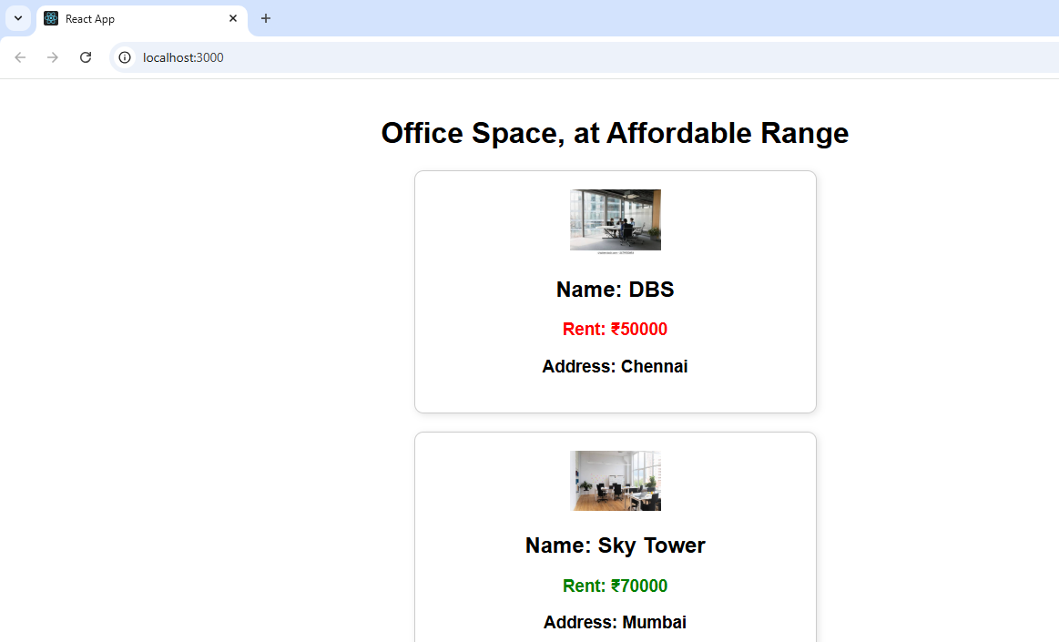

11. ReactJS-HOL

App.js

import React, { useState } from "react";

import CurrencyConverter from "./CurrencyConverter.js";

import "./App.css";

*function* App() {

*const* [count, setCount] = useState(0);

  // Multiple methods for Increment

*const* handleIncrement = () *=>* {

    incrementCount();

    sayHello();

  };

*const* incrementCount = () *=>* {

    setCount(count + 1);

  };

*const* sayHello = () *=>* {

    alert("Hello! Counter was increased.");

  };

*const* handleDecrement = () *=>* {

    setCount(count - 1);

  };

  // Function with argument

*const* sayMessage = (*msg*) *=>* {

    alert(*msg*);

  };

  // Synthetic event

*const* handleClick = (*e*) *=>* {

    alert("I was clicked");

  };

  return (

    <div className="App">

      <h1>🧪 Event Examples App</h1>

      <div className="section">

        <p>Value: {count}</p>

        <button onClick={handleIncrement}>Increment</button>

        <button onClick={handleDecrement}>Decrement</button>

      </div>

      <div className="section">

        <button onClick={() *=>* sayMessage("Welcome!")}>Say Welcome</button>

      </div>

      <div className="section">

        <button onClick={handleClick}>Click on me!</button>

      </div>

      <div className="section">

        <*CurrencyConverter* />

      </div>

    </div>

  );

}

export default App;

CurrencyConverter.js

import React, { useState } from "react";

*function* CurrencyConverter() {

*const* [amount, setAmount] = useState("");

*const* [currency, setCurrency] = useState("Euro");

*const* [converted, setConverted] = useState("");

*const* handleSubmit = (*e*) *=>* {

*e*.preventDefault();

*let* result;

*const* amountNum = parseFloat(amount);

    if (isNaN(amountNum)) {

      alert("Please enter a valid number");

      return;

    }

    if (currency === "Euro") {

      result = amountNum * 0.011;

    } else if (currency === "USD") {

      result = amountNum * 0.012;

    } else {

      alert("Unsupported currency selected");

      return;

    }

*const* message = `Converting to ${currency} Amount is ${result.toFixed(2)}`;

    alert(message);

    setConverted(`${message}`);

  };

  return (

    <div>

      <h1 style={{ color: "green" }}>Currency Convertor!!!</h1>

      <form onSubmit={handleSubmit}>

        <label>Amount:</label><br />

        <input

          type="number"

          value={amount}

          onChange={(*e*) *=>* setAmount(*e*.target.value)}

          required

        />

        <br /><br />

        <label>Currency:</label><br />

        <select

          value={currency}

          onChange={(*e*) *=>* setCurrency(*e*.target.value)}

        >

          <option value="Euro">Euro</option>

          <option value="USD">USD</option>

        </select>

        <br /><br />

        <button type="submit">Submit</button>

      </form>

      {/* Show converted amount */}

      {converted && (

        <h3 style={{ color: "blue" }}>{converted}</h3>

      )}

    </div>

  );

}

export default CurrencyConverter;

App.css

.App {

*text-align*: center;

*font-family*: sans-serif;

*padding*: 30px;

}

.section {

*margin*: 20px 0;

}

button {

*margin*: 5px;

*padding*: 8px 12px;

*cursor*: pointer;

}

Output:

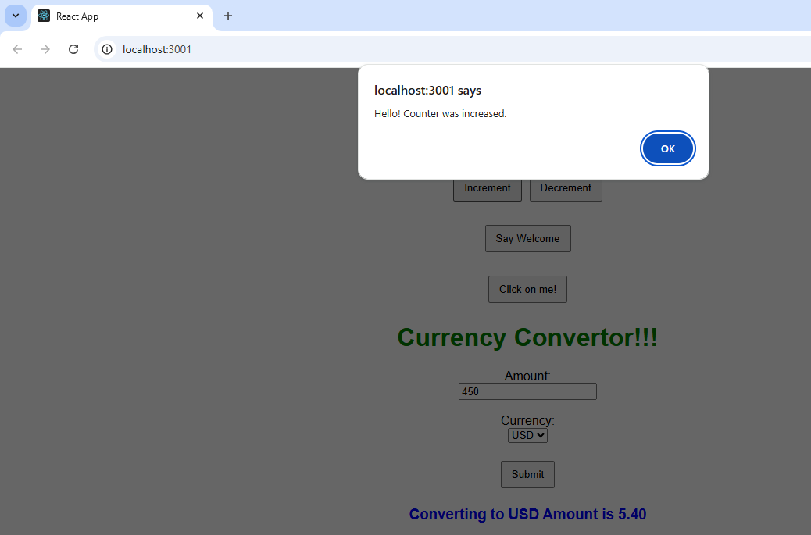

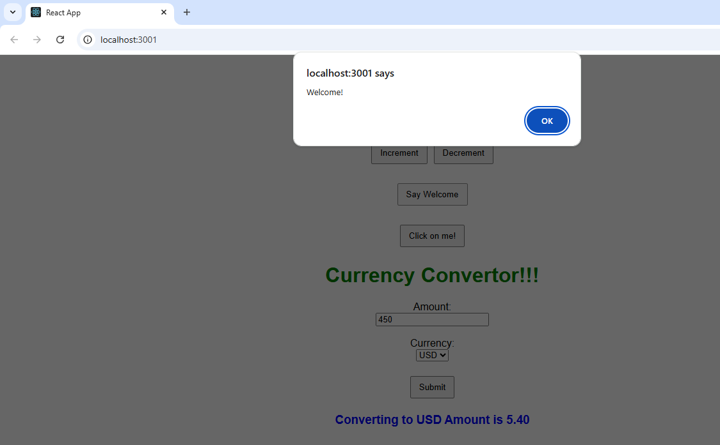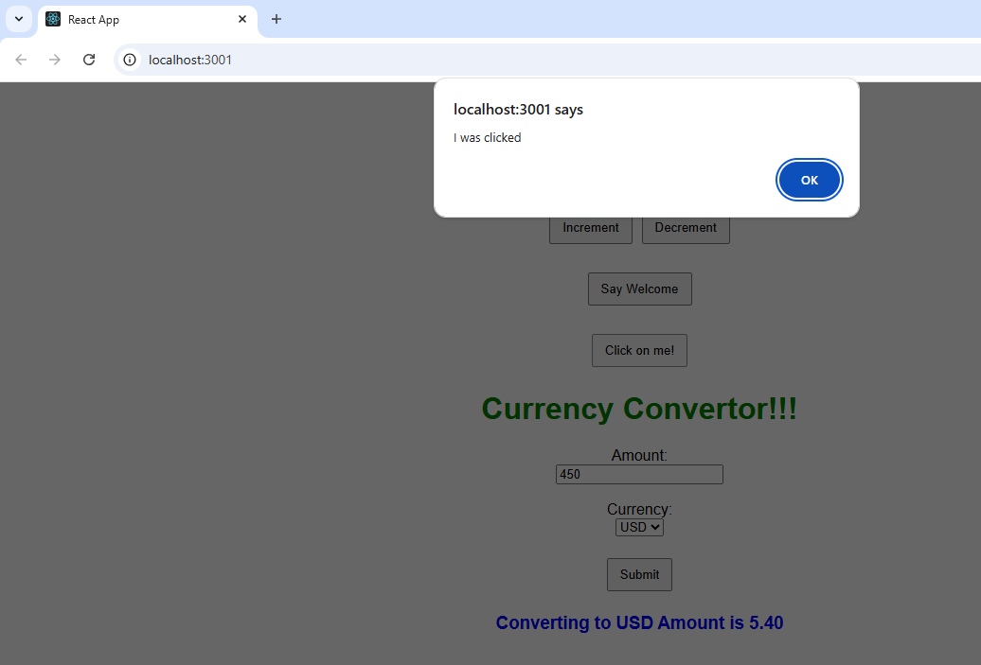

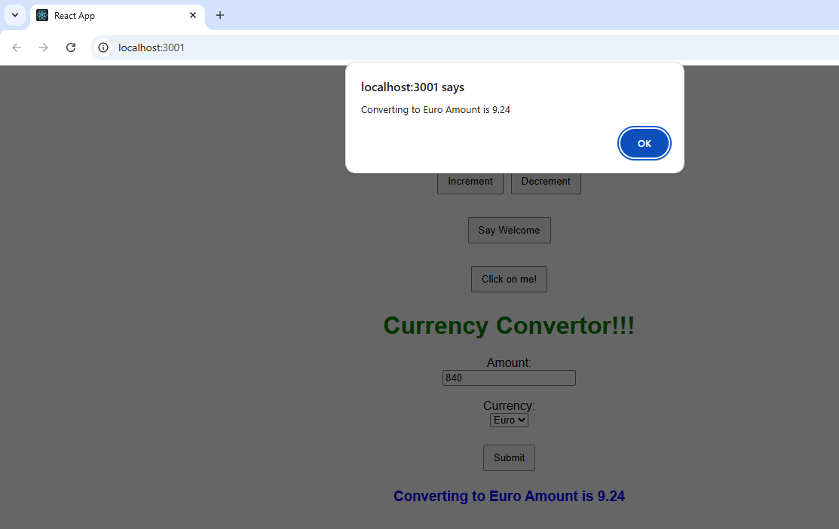

12. ReactJS-HOL

GuestPage.js

import React from 'react';

import FlightDetails from './FlightDetails';

*function* GuestPage() {

  return (

    <div>

      <h2>Welcome, Guest!</h2>

      <p>Please login to book tickets.</p>

      <*FlightDetails* />

    </div>

  );

}

export default GuestPage;

UserPage.js

import React, { useState } from 'react';

import FlightDetails from './FlightDetails';

*function* UserPage() {

*const* [selectedFlights, setSelectedFlights] = useState([]);

*const* [ticketCount, setTicketCount] = useState(1);

*const* flights = [

    { id: 1, price: 3000 },

    { id: 2, price: 3500 },

    { id: 3, price: 2500 },

    { id: 4, price: 4000 },

    { id: 5, price: 1500 },

    { id: 6, price: 2700 },

    { id: 7, price: 3200 },

    { id: 8, price: 3100 }

  ];

*const* handleFlightSelection = (*flightId*) *=>* {

    setSelectedFlights(*prev* *=>*

*prev*.includes(*flightId*)

        ? *prev*.filter(*id* *=>* *id* !== *flightId*)

        : [...*prev*, *flightId*]

    );

  };

*const* handleBook = () *=>* {

    if (selectedFlights.length === 0) {

      alert('Please select at least one flight.');

      return;

    }

*const* selectedFlightDetails = flights.filter(*f* *=>* selectedFlights.includes(*f*.id));

*const* totalPrice = selectedFlightDetails.reduce((*acc*, *flight*) *=>* *acc* + *flight*.price, 0) * ticketCount;

    alert(`Booking Summary:

    Flights selected: ${selectedFlights.join(', ')}

    Tickets: ${ticketCount}

    Total Amount: ₹${totalPrice}`);

  };

  return (

    <div>

      <h2>Welcome, User!</h2>

      <*FlightDetails*

        selectedFlights={selectedFlights}

        onSelect={handleFlightSelection}

        showCheckboxes={true}

      />

      <div style={{ marginTop: '20px' }}>

        <label>

          Number of Tickets:&nbsp;

          <input

            type="number"

            min="1"

            value={ticketCount}

            onChange={(*e*) *=>* setTicketCount(parseInt(*e*.target.value))}

          />

        </label>

      </div>

      <button style={{ marginTop: '10px' }} onClick={handleBook}>

        Book Tickets

      </button>

    </div>

  );

}

export default UserPage;

FlightDetails.js

import React from 'react';

*function* FlightDetails({ *selectedFlights*, *onSelect*, *showCheckboxes* }) {

*const* flights = [

    { id: 1, from: 'Delhi', to: 'Mumbai', time: '10:00 AM', company: 'IndiGo', price: 3000 },

    { id: 2, from: 'Kolkata', to: 'Bangalore', time: '3:00 PM', company: 'SpiceJet', price: 3500 },

    { id: 3, from: 'Chennai', to: 'Hyderabad', time: '6:00 PM', company: 'Air India', price: 2500 },

    { id: 4, from: 'Delhi', to: 'Kolkata', time: '8:00 AM', company: 'Vistara', price: 4000 },

    { id: 5, from: 'Mumbai', to: 'Pune', time: '9:30 AM', company: 'Go First', price: 1500 },

    { id: 6, from: 'Bangalore', to: 'Chennai', time: '11:45 AM', company: 'Akasa Air', price: 2700 },

    { id: 7, from: 'Hyderabad', to: 'Delhi', time: '2:00 PM', company: 'IndiGo', price: 3200 },

    { id: 8, from: 'Mumbai', to: 'Jaipur', time: '5:15 PM', company: 'SpiceJet', price: 3100 }

  ];

  return (

    <div>

      <h3>Available Flights:</h3>

      <table border="1" cellPadding="8">

        <thead>

          <tr>

            {*showCheckboxes* && <th>Select</th>}

            <th>From</th>

            <th>To</th>

            <th>Time</th>

            <th>Company</th>

            <th>Price (₹)</th>

          </tr>

        </thead>

        <tbody>

          {flights.map(*flight* *=>* (

            <tr key={*flight*.id}>

              {*showCheckboxes* && (

                <td>

                  <input

                    type="checkbox"

                    checked={*selectedFlights*.includes(*flight*.id)}

                    onChange={() *=>* onSelect(*flight*.id)}

                  />

                </td>

              )}

              <td>{*flight*.from}</td>

              <td>{*flight*.to}</td>

              <td>{*flight*.time}</td>

              <td>{*flight*.company}</td>

              <td>{*flight*.price}</td>

            </tr>

          ))}

        </tbody>

      </table>

    </div>

  );

}

export default FlightDetails;

App.js

import React, { useState } from 'react';

import GuestPage from './components/GuestPage';

import UserPage from './components/UserPage';

*function* App() {

*const* [isLoggedIn, setIsLoggedIn] = useState(false);

*const* handleLoginLogout = () *=>* {

    setIsLoggedIn(!isLoggedIn);

  };

  return (

    <div style={{ textAlign: 'center' }}>

      <h1>Ticket Booking App ✈️</h1>

      <button onClick={handleLoginLogout}>

        {isLoggedIn ? 'Logout' : 'Login'}

      </button>

      <hr />

      {isLoggedIn ? <*UserPage* /> : <*GuestPage* />}

    </div>

  );

}

export default App;

Output:

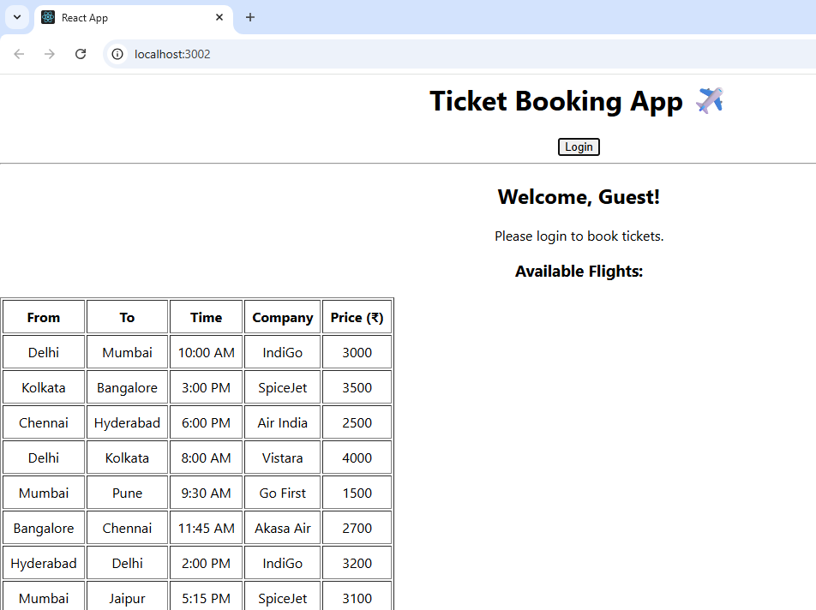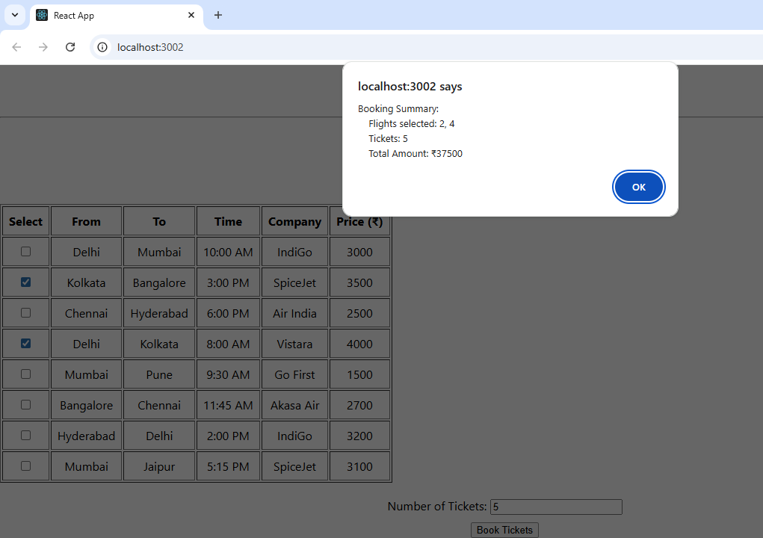

13. ReactJS-HOL

Blogs.js

export *const* blogs = [

  {

    title: 'React Learning',

    author: 'Stephen Biz',

    content: 'Welcome to learning React!'

  },

  {

    title: 'Installation',

    author: 'Schewzdenier',

    content: 'You can install React from npm.'

  }

];

Books.js

export *const* books = [

  { id: 101, bname: 'Master React', price: 670 },

  { id: 102, bname: 'Deep Dive into Angular 11', price: 800 },

  { id: 103, bname: 'Mongo Essentials', price: 450 }

];

Courses.js

console.log("Exported courses loaded");

export *const* courses = [

  { name: 'Angular', date: '4/5/2021' },

  { name: 'React', date: '6/3/2021' } // corrected typo in year

];

BlogDetails.js

*function* BlogDetails({ *blogs* }) {

  return (

    <div className="column">

      <h2>Blog Details</h2>

      {*blogs*.map((*blog*, *index*) *=>* (

        <div key={*index*}>

          <strong>{*blog*.title}</strong><br />

          <em>{*blog*.author}</em><br />

          {*blog*.content}

        </div>

      ))}

    </div>

  );

}

export default BlogDetails;

BookDetails.js

*function* BookDetails({ *books* }) {

  return (

    <div className="column">

      <h2>Book Details</h2>

      {*books*.map(*book* *=>* (

        <div key={*book*.id}>

          <strong>{*book*.bname}</strong><br />

          {*book*.price}

        </div>

      ))}

    </div>

  );

}

export default BookDetails;

CourseDetails.js

*function* CourseDetails({ *courses* }) {

  return (

    <div className="column">

      <h2>Course Details</h2>

      {*courses*.map((*course*, *index*) *=>* (

        <div key={*index*}>

          <strong>{*course*.name}</strong><br />

          {*course*.date}

        </div>

      ))}

    </div>

  );

}

export default CourseDetails;

App.js

import './App.css';

import { blogs } from './data/blogs';

import { courses } from './data/courses';

import { books } from './data/books';

import BookDetails from './components/BookDetails';

import BlogDetails from './components/BlogDetails';

import CourseDetails from './components/CourseDetails';

*function* App() {

  return (

    <div className="container">

      <*CourseDetails* courses={courses} />

      <*BookDetails* books={books} />

      <*BlogDetails* blogs={blogs} />

    </div>

  );

}

export default App;

App.css

.container {

*display*: flex;

*justify-content*: space-around;

*padding*: 30px;

}

.column {

*width*: 30%;

*padding*: 10px;

*border-right*: 3px solid green;

}

.column:last-child {

*border-right*: none;

}

h2 {

*font-weight*: bold;

*font-size*: 1.5em;

*margin-bottom*: 15px;

}

strong {

*font-size*: 1.1em;

}

em {

*display*: block;

*font-style*: italic;

*margin-bottom*: 5px;

}

Output:

